We need to attach working set for search & file name lookup under Package explorer.

Right click in Package Explorer Window - > Import -> Git -> Projects from Git -

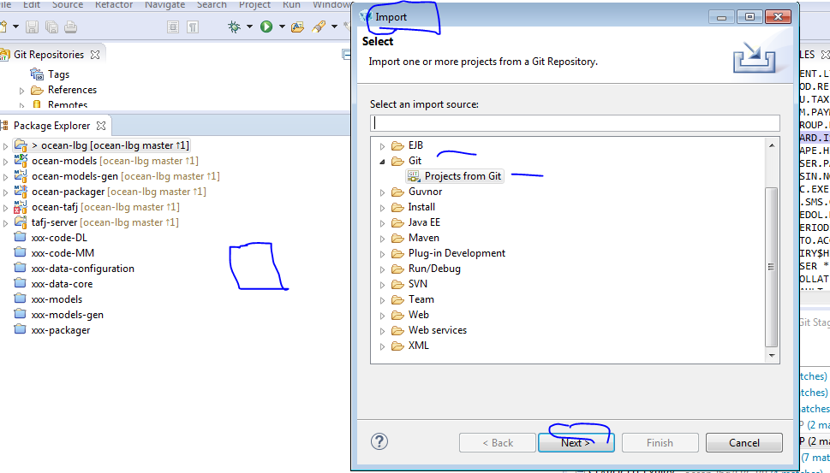

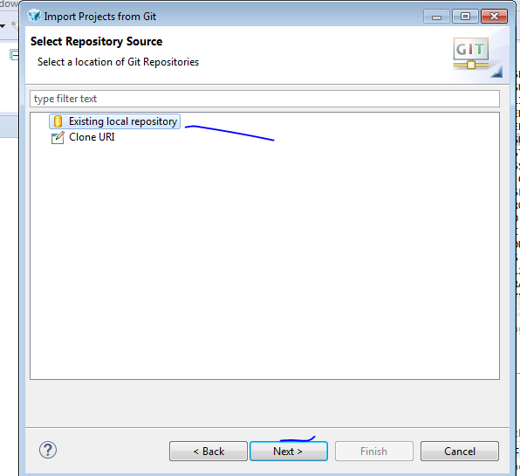

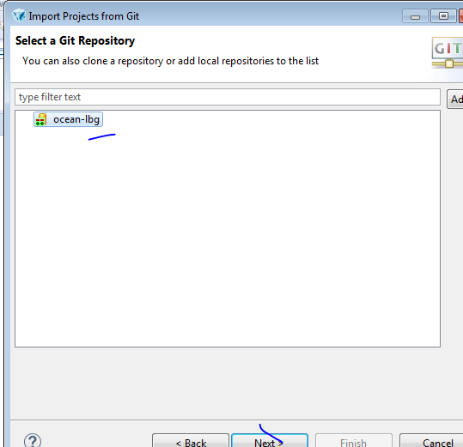

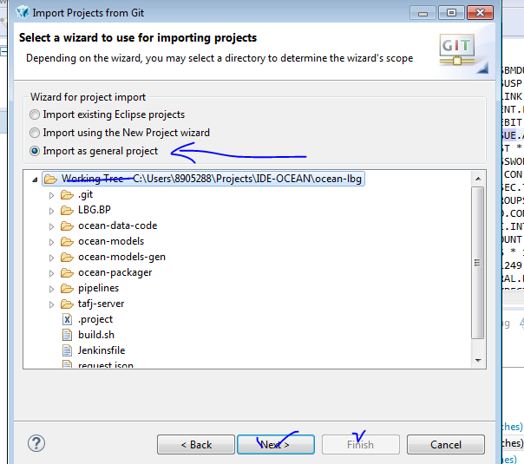

Hit Next & then Finish button to get project linked to Package explorer.

And now, you are set to explore!! – Find file , search in file etc..

1. Ctrl + H to search string in file

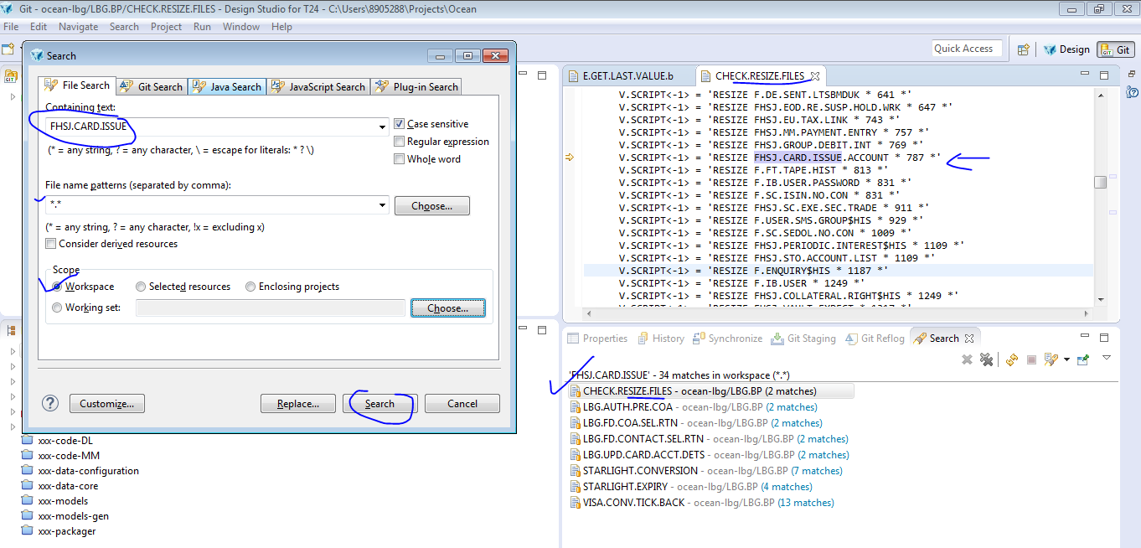

1. Open needy file without traversing under working dir & with file name search with Ctrl + Shift + R

